Lab 04 – Writing functions

COMP130 - Introduction to Computing
Dickinson College
Instructor: John MacCormick

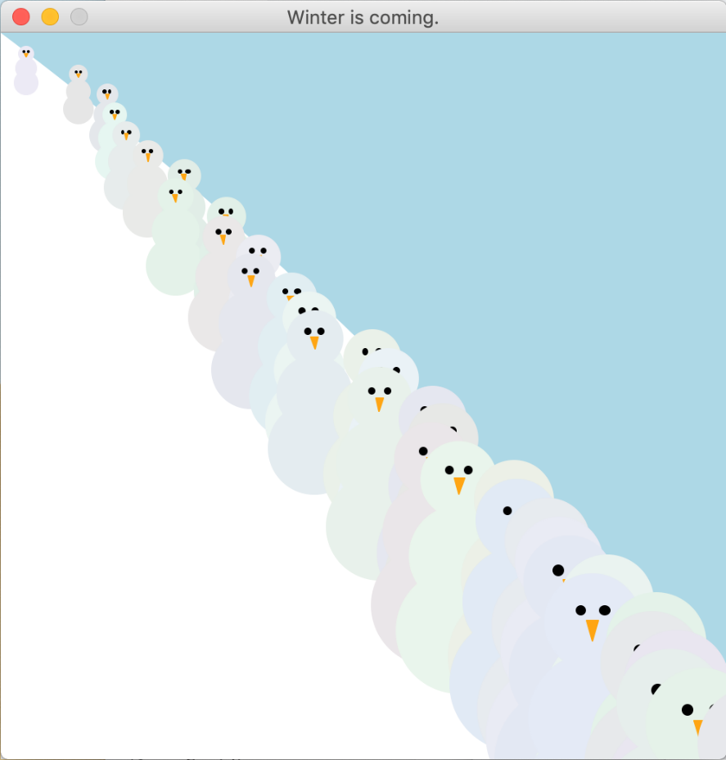
Your task for this lab is to write a complete program that uses the graphics.py module to create a picture similar to the one shown here. This is a picture of some snowthem wandering down a hillside. (The word “snowthem” seems to be a gender-neutral word for “snowman” or “snowmen”.)

Your program should be written in a single file called snowthem.py. This is the only file submitted to Moodle for this lab. It is possible to receive a high grade without completing the whole picture. At a minimum, aim to complete a function that draws a single snowthem at a given $x,y$-position on the picture (this will score at least 85% if working correctly).

Guidelines:
1. Use functions to encapsulate each piece of this task. For example, you may have a draw_a_snowthem function which calls several other functions such as draw_body, draw_eyes, and draw_nose. Each of these would have parameters to specify the location and perhaps also the size of the item being drawn.
2. Use incremental development. That is, divide your task into meaningful subtasks that are as small as possible. Implement and test each subtask before moving on. For example, it may be easiest to start with draw_nose or draw_body.
3. Use the standard layout of a Python program: imports at the top, then all the function definitions, then a small amount of “top-level” code at the bottom. For our purposes, top-level code is any code that is not inside a function definition. If you have more than a few lines of top-level code, move it into a function and invoke the function in the top-level code instead.

Acknowledgment. This lab was originally authored by Lev Fruchter. It was adapted and edited by John MacCormick.

